Mutoshi Cobalt Pilot Project, DRC: Transforming ASM for increased productivity, safer working conditions, and fairer female earnings

Author: Stephanie Shumsky*
Contributors: Sara Johansson de Silva,** Tove Strauss,** Nene Morisho***
Organizations: *Pact, Mines to Markets; **Independent Researchers; *** Pole Institute

Introduction
A significant proportion of global cobalt production originates from ASM in the Democratic Republic of the Congo (DRC). An estimated 20-30 percent (Clowes and Kavanagh, 2020) of the 100,000 metric tons of cobalt produced in DRC in 2019 (USGS, 2020) comes from ASM, providing an essential livelihood for some 200,000 people (Fritz et al., 2018). While ASM cobalt production can come with significant health, safety and human rights risks, it is vital to the world supply and required to meet the growing demand for battery metals as part of the clean energy revolution (Hund et al., 2020). Rather than ignoring the issues or shunning ASM, the global commodities trader Trafigura chose to work to improve the situation and integrate responsible ASM into their mineral supply chain. The Mutoshi Cobalt Pilot Project in Kolwezi, DRC aims to transforms working conditions and the lives of those impacted, while also controlling supply chain risks for Trafigura’s business.
Built into the marketing agreement for Mutoshi’s cobalt hydroxide from the from the start (Shalina Resources, 2018), and with strong collaboration from the DRC government agencies including the Service d’Assistance et d’Encadrement des Mines Artisanales et de Petit Echelle (SAEMAPE), in February 2018 the mine operating company, Chemaf, partnered with Trafigura to officially provide site access and technical support to a local ASM cooperative COMIAKOL, that had been operating informally on the site for more than 20 years. A comprehensive package of practical assistance was designed to enable COMIAKOL to safely conduct semi-mechanized mining and increase their productive capacity. It includes geological support through locating minerals, analysis, and mine planning; mechanized assistance such as preparation and cleaning of the site to allow safe access; as well as training, provision of safety equipment and amenities. The package was supported by the global NGO Pact to manage the overall delivery of the pilot project, as well as Kumi Consulting as independent assessors against Trafigura’s responsible sourcing policies and expectations.
The original objective was to ensure that the minerals sold by COMIAKOL to Chemaf were sourced in accordance with both the OECD Due Diligence Guidance and Trafigura's Responsible Sourcing Artisanal and Small-Scale Mining Expectations. However, as the pilot project progressed, notable additional positive impacts on the local social and economic conditions as well as health and safety emerged. Directly related to SDG targets 8.5 and 8.8, respectively. These improvements were particularly felt by female miners participating in the project. The clearest achievement has been for COMIAKOL to record over six million work hours without a lost time incident and no fatalities between the start of the pilot in February 2018 and the temporary suspension of activities on site due to Covid-19 in March 2020.

An Independent Analysis of the Pilot Model Found a Strong Positive Impact on Participating Miners
To understand the impacts of the pilot project better, in mid-2019 Trafigura commissioned an independent analysis. Interviews and focus group discussions were conducted with miners and key informants among participating stakeholders (Pilot Project Group). A quantitative survey was also administered to 319 artisanal miners from this group, and a Comparator Group comprising 110 artisanal miners from Kapata – an informal ASM site several hour’s drive from Mutoshi (Table 2). This case study provides a summary of these findings from the full research report (Johansson de Silva, Strauss, Morisho, 2019) to highlight the positive impacts on SDG8 in two key areas: decent work through increased productivity, and health and safety.
Table 2. Biographical Data of Artisanal Miners in Pilot Project Group versus Comparator Group
 | Pilot Project Group |  |  | Comparator Group
Artisanal Miners | Men | Women | Total | Men | Women | Total
Number | 196 | 123 | 319 | 60 | 50 | 110
Gender share of total (percent) | 61% | 39% | - | 55% | 45% | -
Age (years)
Average | 34 | 40 | 37 | 35 | 37 | 36
Youngest |  |  | 19 |  |  | 20
Oldest |  |  | 69 |  |  | 63
Education (highest level completed)
Below secondary | 75% | 96% | 83% | 70% | 96% | 82%
Households (average number of persons)
Average household size | 5.9 | 6.2 | 6.0 | 6.0 | 7.2 | 6.5
Age dependents (<15 or >64 years) | 2.9 | 3.2 | 3.0 | 2.8 | 3.5 | 3.1
Other household members contributing to income | 0.6 | 0.8 | 0.7 | 0.8 | 1.2 | 1.0
Source: Johansson de Silva, Strauss, Morisho, 2019, 19

Key Socio-Economic Findings
The analysis showed that when implemented with all its components, the project had a strong positive impact on participating miners and contributed significantly to the local economy, but it has not insulated COMIAKOL’s members against the dramatic fall in price of cobalt. Many positive effects, for both male and female workers, have nonetheless endured.
- The project has had significant and positive impacts on productivity of participating artisanal miners when they are on site. Overburden stripping, provision of geological information, and better work-place organization has helped increase output per hour worked.
- Reduced operating costs. As a result of open-pit mining procedures and Chemaf being the only buyer, the project reduced the costs incurred by miners to safeguard their sacks of minerals while transported to trading places by two thirds and eliminated bribes paid to corrupt military and security forces (which some estimated at US$1.20-1.80 per day).
- Female artisanal miners have diversified their roles to include better paid positions and earn approximately two and a half times more than before. While 94 percent of women in the Comparator Group worked in the lowest paid role as washers earning an average US$34 per month, through the pilot women at Mutoshi have moved into higher paid, once typically male dominated roles. Now 77 percent of women work as collectors (39 percent), diggers (31 percent), and team leader diggers (7 percent) earning over close to and above US$100 per month (Figure 1).
- Mine site harassment has decreased. Women working at the Mutoshi project report that workplace harassment from male colleagues has decreased and that improved site sanitation such as clean water and toilets has had a positive impact on their health and wellbeing.
- Positive economic and social spillover effects from the mine site to the local community. There have been noticeable impacts on the local economy, including the creation of new businesses in response to higher demand for goods and services. Miners spend an estimated three quarters of their total spending on goods that have been locally produced. For every 1,000 miners at the site, the local economic impact is estimated at around US$1 million per year. Meanwhile, the majority of new businesses started in the area were owned by women evidencing greater confidence and freedoms as a result of the reduced harassment and bribes sought by government agents.
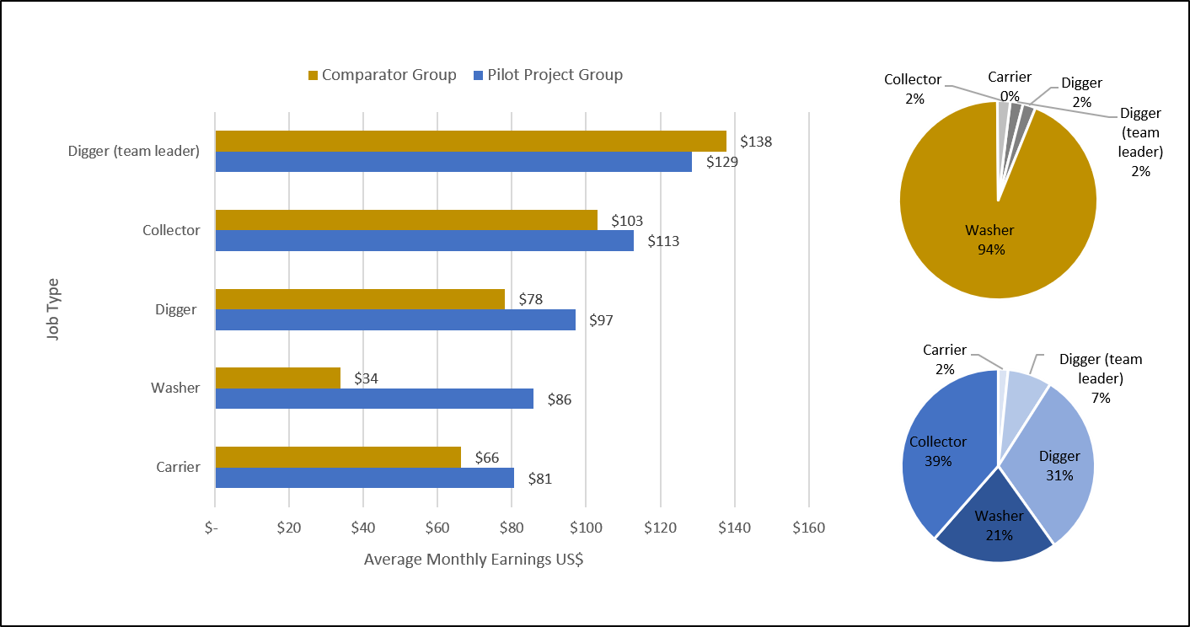
Figure 1: Increased Earnings and Women’s Job Diversification of Mutoshi Pilot Participants vs. Comparator Group
Source: Johansson de Silva, Strauss, Morisho, 2019

Key Health and Safety Findings
To ensure a safe operating environment for COMIAKOL, expert identification and management of risks by Chemaf’s Health and Safety management is combined with simple site rules. A site risk register is regularly updated and a mixed team of miners, Pact staff, government agents and experts from Chemaf conduct inspections multiple times per week to ensure compliance, train miners on best practices, and gather information. Every Monday morning the cooperative management team meets to reinforce key safety topics for the workers, from the importance of wearing steel-toe boots, to how to prevent the spread of illnesses like cholera, and most recently Covid-19.
Access to the site is limited to COMIAKOL members, all of whom have been verified to be over 18 years old, alcohol tests are conducted at random to prevent miners from working under the influence, and pit depths are limited to 10 meters or less with most miners working in the open on the surface using simple hand tools while wearing personal protective equipment. Free healthcare is also available on site, where a doctor treats small injuries and common illnesses such as malaria and diarrheal diseases. Clean drinking water and sanitary facilities provided by Chemaf mean that the miners can apply these important hygiene lessons reinforcing the practices and preventing disease outbreaks in the workplace and local community. As found by the independent analysis, this collaborative approach with COMIAKOL has resulted in notable improvements in health and safety.
- Working conditions have been remarkably improved. Artisanal miners now work in much more hygienic and less dangerous conditions, and they work fewer hours versus the comparator group; on average 1 hour less per day according to survey results.
- Artisanal miners feel safer at their workplace and can spend more time with their families. These improvements have even been sustained during price fluctuations due to the improved working conditions and stability from joining COMIAKOL cooperative enabling them to return home daily.
- Miners, and particularly female miners, working at the project site are healthier. They are also less absent from work due to illness, and spend less on medication and hospital bills as compared to the control group due to the strict safety and hygiene measures and access to free healthcare on site.
- Over 70 percent of the Mutoshi Pilot Project participants stated that they joined to improve their working conditions with respect to safety. This demonstrates safety is a priority for the workers as well as other actors in the supply chain.

Conclusion
During a favorable price context when all the project deliverables were being implemented, the pilot project functioned very well in terms of improving the livelihoods of miners. The independent analysis shows that the model has had tangible positive economic and health and safety impacts for artisanal miners and their communities and thus could have significant potential to be replicated elsewhere, although more information is needed to ascertain full impact and cost effectiveness. Crucially, these improvements are the result of a unique partnership approach with each organization bringing something different to the table.
- Technical expertise. By working closely with large-scale mining experts from Chemaf, the pilot project benefited from their extensive experience and continued guidance on identifying and managing safety risks. Chemaf also provides some of the resources necessary to manage safety, such as machines to remove waste rock and open the pits to eliminate cave-in risks as well as medical professionals.
- High expectations and cross-sector experience. Trafigura holds the pilot to high standards through their responsible ASM sourcing expectations and audits by Kumi Consulting, pushing COMIAKOL, Chemaf, Pact and SAEMAPE to improve conditions, mitigate risks and continuously improve. Representatives from the commodities trader also regularly visit the site and participate in bi-weekly management calls where safety risks are discussed, and proactive solutions proposed.
- Strong political networks and on-the-ground action. SAEMAPE also provides technical guidance and ground-level monitoring, alongside Pact’s own employees, to train miners and support compliance with Chemaf’s regulations and Trafigura’s expectations. The agency also provides a crucial link to regulators, ensuring that communication channels remain open and the project maintains its political license to operate.
- Commitment to zero harm. Finally, COMIAKOL has integrated a zero-harm approach into every aspect of its business, prioritizing safety training and practical management across its operations. From mineral diggers and washers to transporters and businesspersons, every member of the cooperative undergoes a safety induction and is subject to the site’s regulations.

Acknowledgments
The independent socio-economic impact report was commissioned by the Trafigura Group using research conducted and analyzed by Sara Johansson de Silva, Tove Strauss, and Nene Morisho that was summarized by Stephanie Shumsky of Pact in some sections of this case study. The findings and recommendations represent the views of the author and should not be attributed to the Trafigura Group.

Translated as the ‘Assistance and Management Service for Artisanal and Small Scale Mines’ in English, SAEMAPE a technical service of the National Ministry of Mines and is mandated to support artisanal miners by providing information, resources, training and technical assistance.
London Metal Exchange cobalt prices crashed from an all-time high of US$90,000 per ton in early 2018 to below US$30,000 in mid-2019 and remained at this lower level, slumping again to US$28,500 in June 2020 due in part to oversupply from ASM and industrial mining in DRC and a surplus of cobalt chemicals (Desai, 2019; Johansson de Silva, Strauss, Morisho, 2019; LME, 2020).
The additional local spending attributable to the project is measured as the difference in local spending between the project group and the comparator group.
On average, the miners in the pilot project group estimated they were absent about four days while the Comparator Group were absent more than twice that number. It is also noteworthy that women in the comparator group were absent almost three times more than the women in the project group.

